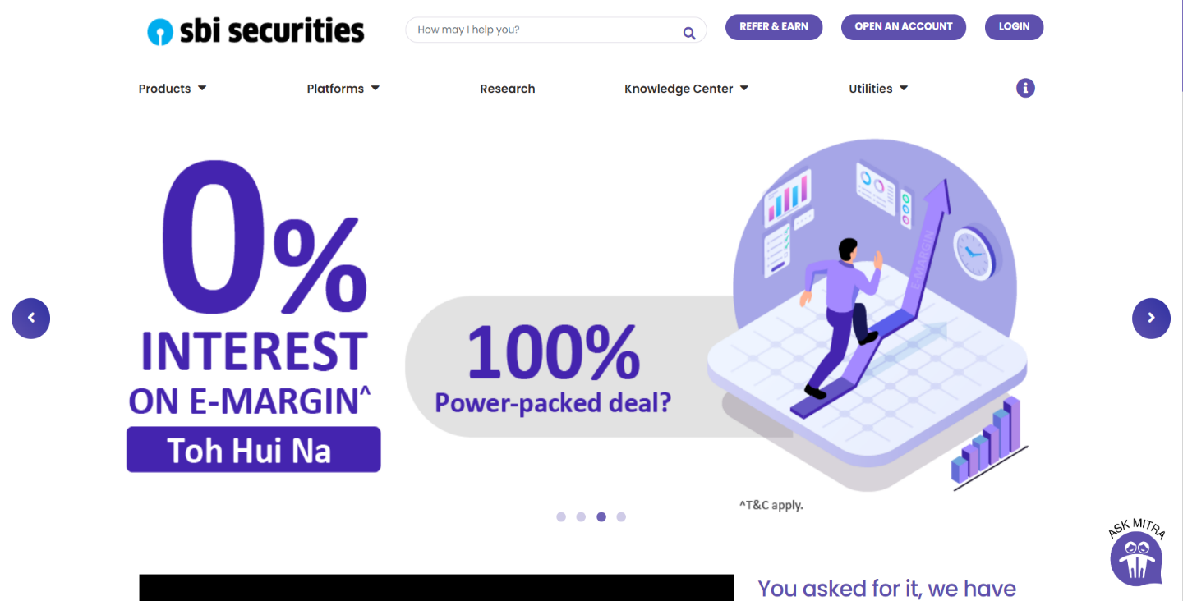

PROJECT: SBI securities.

SBI **Securities**, is a wholly-owned subsidiary of SBI Capital Markets Ltd and a part of the **State Bank** group, the largest conglomerate in India which offer broking services and a wide range of financial and advisory services. Since we started operations in 2006. sbi securities carry the proud lineage of SBI – a brand trusted by every Indian. Sbi securities offer a pool of investment products and services across various asset classes. You can choose to invest in equity, derivatives, mutual funds, corporate fixed deposits, bonds, insurance, loans and NCDs suiting your financial needs. With our newly launched trading platform, managing investments has become easier than ever.

**HOME PAGE**

# HEADER

# Logo of the web site

1. Search bar
2. Refer & earn (button)
3. Open an Account (sign up button)
4. Login (button)

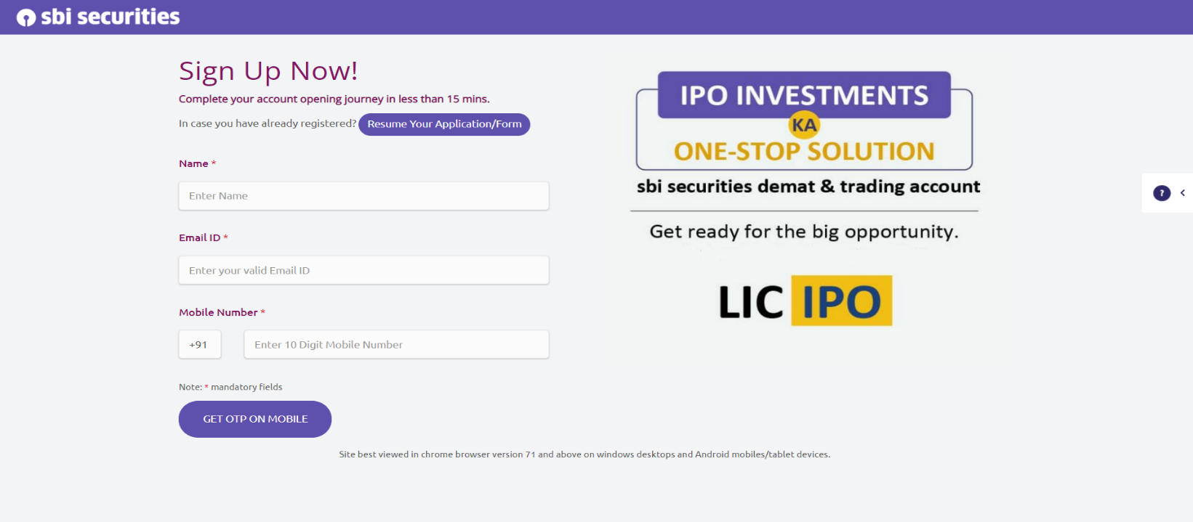**4. OPEN AN ACCOUNT (SIGN UP PAGE)**

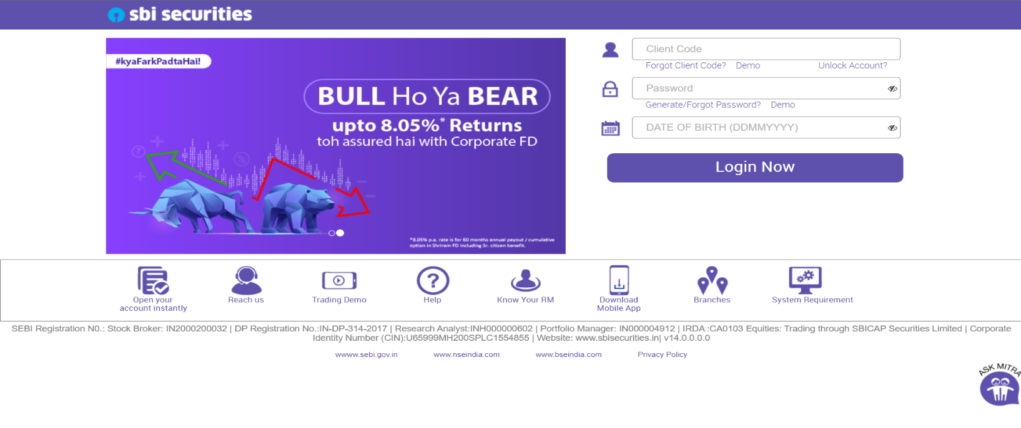**5. LOGIN BUTTON (LOGIN PAGE)**

* AFTER LOGIN PAGE
  + 1. HEADER – logo, live-index & search bar, account details, theme, logout &settings.
    2. NAVIGATION BAR
       1. Home
       2. Portfolio
       3. Equity
       4. Derivatives
       5. Mutual Fund
       6. Fixed Income
       7. Limits (hold, release &transfer money)
       8. Historical Reports
       9. IPO
       10. Refer & Earn
* 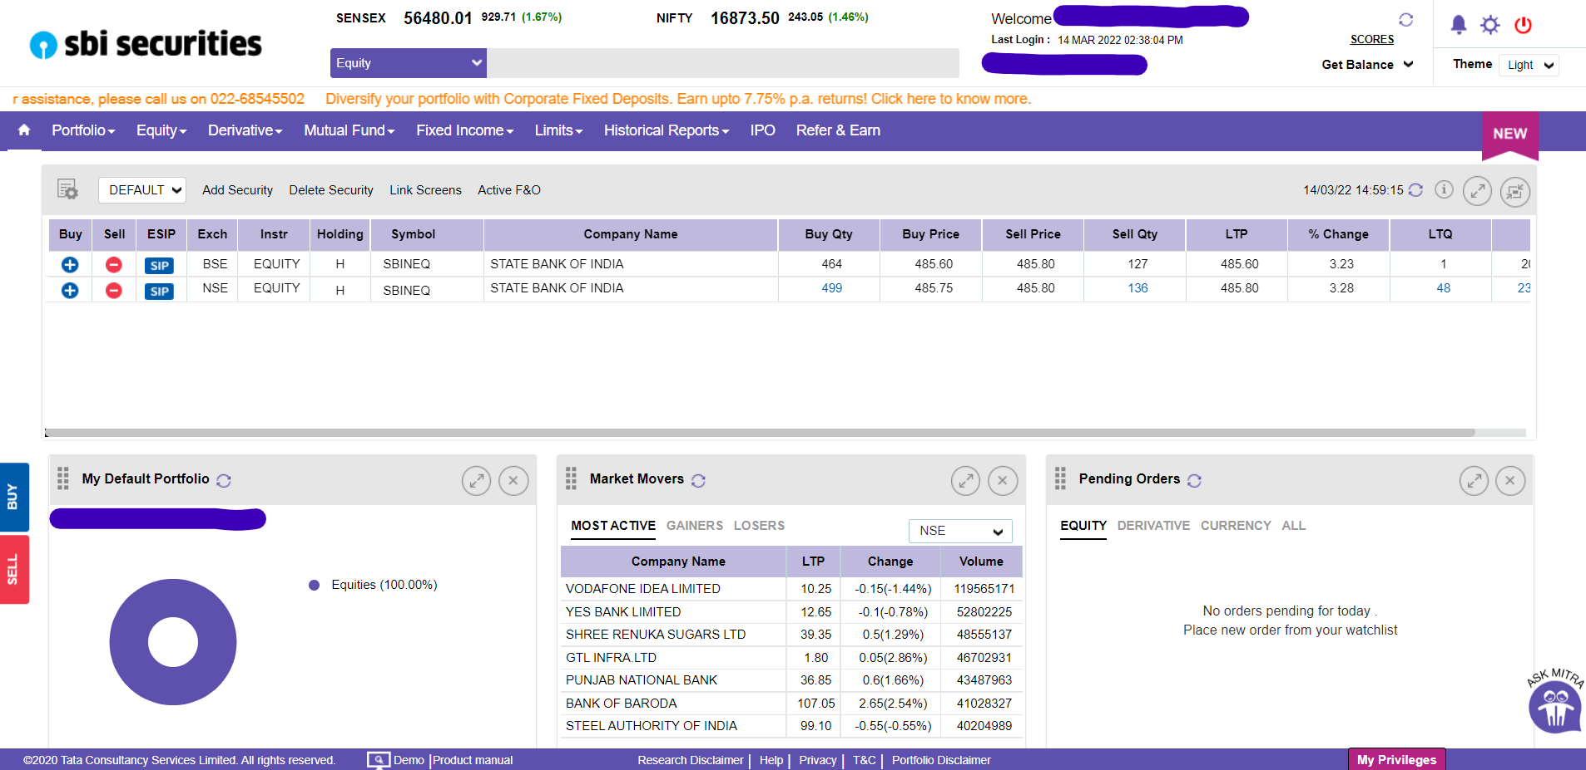**AFTER LOGIN PAGE(default home)**

**b. PORTFOLIO (DROP DOWN)**

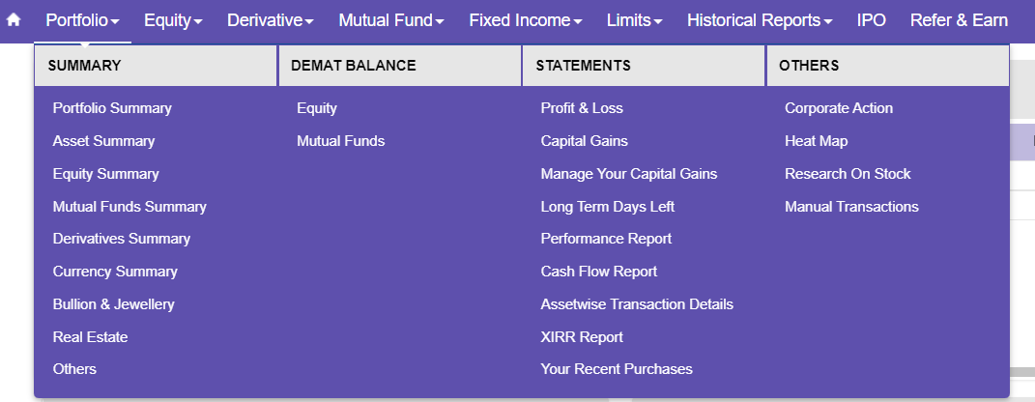

* NAVIGATION BAR (home page)
  1. Product (drop down)
  2. Platform (drop down)
  3. Research
  4. Knowledge center (drop down)
  5. Utilities (drop down)
  6. [i] contact us (side bar)

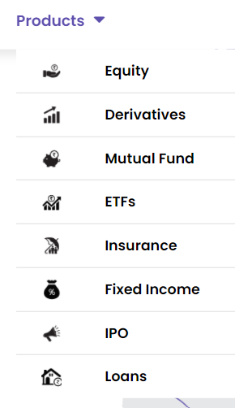**PRODUCT (DROP DOWN)**

**6. [i] CONTACT US (SIDE BAR)**

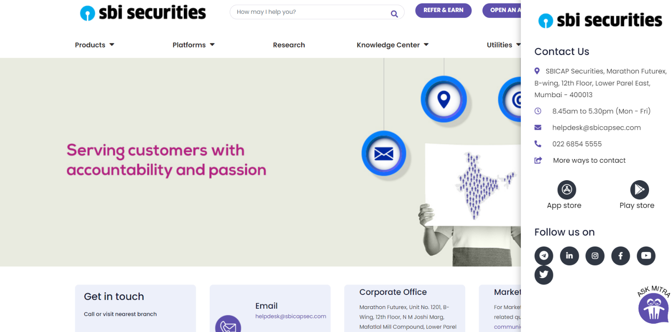

* MAIN CONTENT (home page)

1. Section- Images (Carousel)
2. Section- Video with content
3. Section- Content with Image
4. Section- Image with content
5. Article- blog in cards (Carousel)
6. Section- what people say
7. Section- Awards

* FOOTER

1. About Us
2. Platforms
3. Login
4. Important Communication
5. Knowledge Center
6. Useful Links
7. Where We Are
8. Our App’s
9. All rights and Authorities

* **FOOTER**

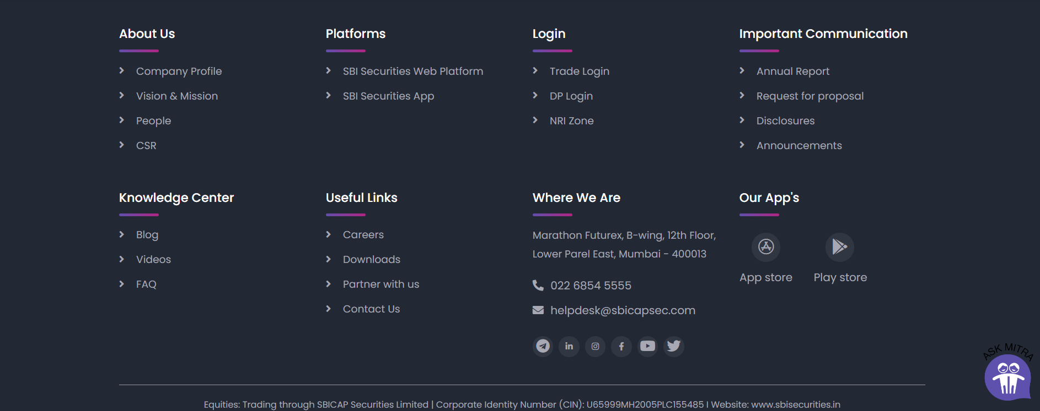

* Technologies used in SBI securities.

Front-end:

Html

CSS

Bootstrap

React

Dynamic:

JavaScript

Ci/Cd with AWS

Login And Logout (oauth and jwt)

Database:

Mongodb

Json Data

Code Compilers:

Visual Studio Code (VS code)

Git bash

Git hub

Node.js